# Promax Decision Support System

Project Documentation Submitted

To the Faculty of School of

Computing and Information Technologies

Of

Asia Pacific College

In Partial Fulfillment of the Requirements for the subject

Applied Projects

By

John Lloyd B. Briones

Rolando Aurelio Talag

Denzel Oribiana

Manuel Serrano

Table of Contents

Promax Decision Support System 1

ABSTRACT 2

List of Figures, List of Tables, List of Notations 4

I. Introduction 5

1.1. Background of the Problem 5

1.2. Statement of the Problem 5

1.3. Objectives 6

1.4. Significance of the Study 6

1.5. Scope and Limitations 7

1.6. Context Diagram 8

II. Review of Related Literature 9

Related Studies 9

Related Systems 11

III. Technical Background 12

IV. Design and Methodology 13

Initial Findings and Plans for the Succeeding Term 14

# ABSTRACT

As modern technology and its uses continue to grow in this fast-paced and changing world, there has arisen a need to follow the trends in order to cope with the constant changes of the environment. The use of computerized systems in the workplace has increased due to their ease of use and the benefits that they offer to the workplace. Computerized systems bring various benefits such as improved data management, real-time updates, and data security. With these benefits the various issues caused by paper-based systems can be solved and amended.

This paper presents the creation of a Payment Tracking System for the use of the development team’s client Promax Realty Corp. The payment system was made to replace the company’s current paper-based system by automating their current business process. The payment system will also be integrated with a decision support system to supplement the system’s functions. The data contained in the payment system will be used to determine the Decision Support System’s use and functions. The DSS will be presented through the dashboard which will display the information for the system’s ease of use.

Keywords: *Decision Support, Payment Systems, Paper-based System, Business Automation*

# 

# List of Figures, List of Tables, List of Notations

**Event Table**

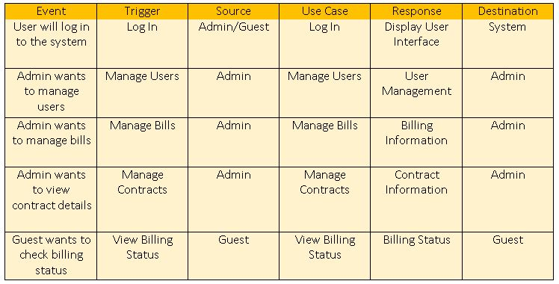

# Introduction

### Background of the Problem

The key to a successful growth is the creation of a system with the function of providing relevant information on a real-time scale to decision-makers of a business. The critical factor to report automation is the ability to detect record, calculate, and finally inform all entities regarding business-sensitive data. Management of the data is also a critical factor in order to make use of the data to make sound business decisions. The need to locate, update, and modify data is thus deemed important in the business scheme, and to realize this computerized system is needed due to their data processing and data management capabilities. 

### Statement of the Problem

The development team’s client Promax Realty Corporation has recognized the need for computerized systems. Currently the company uses a paper-based system. Where various issues such as data loss, data redundancy, and loss of information have caused problems in their company workflow. A paper-based system also decreases work efficiency and accuracy and is thus deemed obsolete in this fast-paced and growing world.   
 In order to address these issues a Payment System was proposed. To keep track of company transactions, as well as manage and view company's clientele details such as client information, balance, due dates. To increase work efficiency for the business and its overall productivity. In order to elevate the Payment System a Decision Support System (DSS) was included to manage business transactions in an orderly and efficient manner. By incorporating the best practices and the best tools for development, the researchers will be better equipped to disseminate information comprehensively and accurately for the improvement of this client's future business transactions.

How would a system affect the decision making of a business/organization in order to improve efficiency and future transactions?

### Objectives

General Objectives   
● To create a working system that would meet the client’s requirements   
● To improve the client company’s current business system

Specific Objectives   
● To create a payment tracking system for the company and its clients   
● To successfully integrate a DSS into the payment system for the client’s business use   
● To determine the required components and information that will be necessary for DSS implementation in the business.

### Significance of the Study

The result of this study will be beneficial to the following agencies:

● To the Promax   
This project was initiated and established in order to create a working system for the Promax Realty Corporation. It will serve to benefit the company’s future by improving and enhancing business transactions, ease the current workflow of the business and better clientele selection. The project will help make the job of the client easier by making the system computerized, thus reducing human errors.

● To the Tenants   
This project will benefit the current tenants of Promax Realty Corporation. This will help their current business relationship as the project will provide the tenants a faster and easier way to perform applications to the company as well as to be notified or updated on their current rental balance.

● To the Future Researchers   
As the current means of performing business transactions are constantly evolving, this research can serve to benefit the future developments of decision support systems or other similar researches that may be undertaken by future researchers. This study could be a reference or basis for other researchers who would want to conduct a similar study.

### Scope and Limitations

This project will be used for Promax Realty Corporation. This will benefit and help the company’s business system through a Payment Tracking System that will be further supplemented by a Decision Support System (DSS). The scope of the Decision Support System will be restricted to the company’s tenant approval decision-making process. Any other applications of the DSS to the business will only be studied when deemed necessary for the project. The team is currently researching and working only on the Payment System. The features of the Decision Support system (DSS) will be applied in future studies. This system will only operate during the billing and payment processes of the company. The system will not handle the filing of taxes towards the bureau of internal revenues. The company will handle this process itself. For future technical support, the development team will be open for on-call support after project turnover.

The project will follow the business process that is currently used by the Promax Realty Corporation.

1. The company offers a minimum 1 year contract for all of their properties
2. The company uses 3 weeks billing periods
3. Thefirst month of the contract will be paid for in full to serve as a contract reservation fee.
4. Tenants are given 3 weeks to pay their rents. Starting from the first day of the billing period.
5. A penalty of 3% of the monthly rental will be asked for if the tenant fails to pay the monthly rental.

### Context Diagram

**Original Context Diagram**

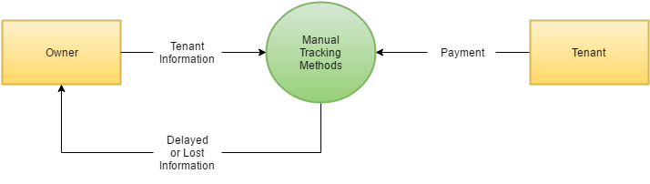

**Proposed Context Diagram**

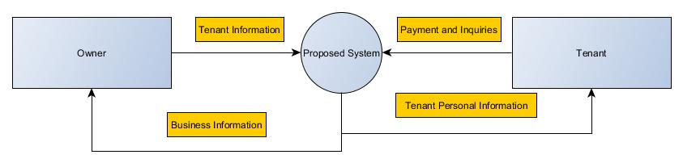

# Review of Related Literature

### Related Studies

**Payment Systems in Malaysia: Recent Developments and Issues**

The article states that Payment systems in Malaysia and in some other countries have been undergoing changes in recent years. Among those changes is the emergence of electronic-based payment systems. The central bank has been playing an active role in shaping the development of payment systems, particularly in the gradual introduction of electronic-based payment schemes. It is believed that by using payment systems the potential to increase efficiency in the economy as whole and each small businesses and firms individually. The payment instruments have increased both the value and volume of transactions per capita use of e-payment instruments in recent years. Small- and medium-sized enterprises could benefit tremendously from the use of e-payment schemes through more efficient business operations, cost reductions, enhanced security, and wider payment channel choices. The article states that small firms and businesses such as Promax Realty Corporation could benefit from payment system.

**Core Principles for Systematically Important Payment Systems**

Safe and efficient payment systems are critical to the effective functioning of the financial system, payment systems are the means by which funds are transferred among banks, and the most significant payment systems are a major channel by which stocks can be transmitted across other financial systems and markets. Payment systems are therefore a key requirement in maintaining and promoting financial stability according to the article. Also, the article states that it is intended for use as universal guidelines to encourage the design and operation of safer and more efficient systematically important payment systems worldwide. The payment system proposed to the client is efficient and effective. This article will help on giving the team some ideas on how to make an effective and efficient design for the payment system.

**Transaction Plan: Consolidating Payment Systems for Improved Efficiency, Security and Usability**

Payment processing has grown ever more complex and the popularity of electronic payment has grown significantly. The number of payment points on campus for colleges and universities has added new payment systems to support electronic transactions for tuition and student fees, housing, parking, bookstore and other campus services. The result has been a patchwork of disconnected systems accompanied by redundancies, inefficiencies, unnecessary costs and security headaches. Colleges and universities can solve many of these problems by stepping back and looking at the big picture of campus transactions. By consolidating multiple payment sloes into a single, unified system for the entire campus that is integrated with the enterprise resource planning (ERP) system, they can save time and money while improving security and user experiences for both students and administrative staff. The article was somehow related to the team’s project because just like the company of the client, the payment for their business has grown just like in colleges and universities like what the article mentioned, so the company needs to upgrade and let go the old system which is being paper based. But before that can happen, the team needed to picture what their client wants for their company. The team will need a plan before they can produce an effective and efficient working payment system.

#### Method and apparatus for tracking multiple payment resources and charging transactions to payment resources in on line transaction processing system

The patent focuses on the payment and transactional functions of a system. The research shows a usable method of accounting the payments. The patent stores transaction information into a database and promptly manages the obtained information into their respective data repositories. The payment methods within this patent can serve as a reference to the methods applied into the project system. Application of such methods into the system requires further study.

#### Application of Decision Support Systems and Its Impact on Human Resources Output: A Study of Selected Universities in Zimbabwe

This is a study that focuses on the use of decision support systems and its effect on human output. The paper initially defines the necessary scope that encompasses the workings of a decision support systems and literature related to the human factor. The Research shows key points that are the Decision Support System (DSS), hardware and software requirements, networking, data analysis, human output. Necessary data were collected from various respondents that are from the managerial positions in a Zimbabwean university with proper knowledge on the inner workings of their organization. The conclusion of this study states that DSSs enhance decision making to a greater extent but is still debated on by various scholars if DSSs potentially remove the human element from the decision making process. The study requests to be performed on various other economical sectors (such as the financial sector) in order to create a definitive theory on the influences of DSSs on Human Output.

### Related Systems

**ONB Oesterreichische National bank euro system**

Payment systems according to the site represent an important component of the financial market infrastructure. They provide financial intermediaries – the economic agents of the financial system – with liquidity and ensure that liquidity flows smoothly between the public sector and households. Payment systems operate on the principle of stability and security as well as the guarantee of fast and cost-efficient transfers. The special feature of such payment systems is that they handle euro transactions in real time and with settlement finality. This is related to what the team wants for the system to do. The team wants the system to be real time, stable and fast so that when a client needs to check or verify something regarding their payment, it is easily located by using the payment system. Thus, it is not time consuming and it will be both convenient for the client and user of the system.

**Payment Systems of the Philippines**

The central bank, Bangko Sentral ng Pilipinas (BSP), previously handled inter-bank wholesale funds payments using a proprietary RTGS-based system or MIPS2 Plus. The improvement of customers’ account depends upon the upgrading of payment infrastructures by individual financial institutions rather than on the further development of payment systems by the financial authorities. Nonetheless, such improvement is vital for the enhancement and efficiency of wholesale funds payment systems in the Philippines. In order for the team to create an effective and efficient payment system, the team needs to research on possible basis for their concept and design. There are some available payment systems out there that the team can use, just like the banks mentioned in the article. Some banks have different based systems. It depends on what they think is working best for them. For the team to know which payment system they can use for their basis of the project, a further study and research is needed.

# Technical Background

**Payment Systems**

Payment Systems are financial systems that support the transfer of funds from multiple transactors. It is done usually through debit-credit transactions among various financial institutions. It mainly consists of a paper-based mechanism that handles articles such as checks and drafts, and a paperless system that manages the electronic transfer of funds in order to manage the transactions. They are mainly used due to their cost efficiency and advanced data handling.

**Decision Support System**

Decision Support Systems (DSS) are interactive computerized systems that are used to help and support the Decision-Making Process from within an organization or business by gathering data and presenting it from a wide range of sources. Decision support systems take various types of information and use various analytical models in order to determine the optimal decision for a specific event. A decision Support System is only meant to support the Decision Maker (Human) and not to make the decision itself. The Decision Maker should use this and other sources of information to help guide in solving problems or making important decisions.

There are different types of Decision Support Systems and each one are meant to be used for a different purpose. They are as followed:

• Communication-driven DSS - This is used for team collaboration and communication, typically through a web service, for example Chats and Online meeting software

• Data-Driven DSS - This utilizes database and data warehouses in order to obtain the optimal solution to given problems, for example computer based databases that have query capabilities

• Document-Driven DSS - This searches related documents or web pages by using specific keywords or search parameters.

• Knowledge Driven DSS - This is used to support not only the business utilizing it but also all entities that interact with the business, for example the customers; moreover it is used to give advice or selection of necessary products or services.

• Model-Driven DSS - This is used to perform optimal decisons by analyzing them and choosing between several options. This also used the entities of the business when making decisions depending on how it is setup.

# Design and Methodology

#### Functions

This part contains functionalities that will be or is part of the proposed system.

#### Client Database

This refers to the systems data storage capabilities that allow the system to store the necessary data of the clients, in an easily viewable format that can be used by the business to easily record and track data. Data in this function are organized according to details such as unit type, unit no., tenant name, deposits, and other classifications.

#### Administrator Rights

This refers to the systems control settings. This allows the changes of various rights and permissions as well as the modifications of accounts.

#### Document Reports

This stores the forms and documents that the system uses to collect data. Files that fall under this function are application forms, contracts, and other miscellaneous forms.

#### Survey Questions

These are questions used for data gathering purposes in order to collect information for the Decision Support System Parameters. Survey questions are used together which document reports and client database in order to generate the desired output.

#### Progress Report

Contains up-to-date information of the current state of the business and displays them graphically in order for the administrator to gain easily view-able access to certain information, such as rental payment, due dates, and contract terms

#### Dashboard

Contains reports, graphs and Diagrams and displays them for the users’ viewing purposes. By gathering data from Promax Realty Corp. the system will display graphs, values and other necessary information in order for the company to monitor and be notified of the payment and contract details, properties, earnings, etc.. The information compiles and analyzes them into an easily understandable model and displays them to the administrator depending on the parameters the administrator has set beforehand in order to view needed information. Most importantly is this will serves as decision support for the company's various situations, circumstances, and needs.

# Initial Findings and Plans for the Succeeding Term

With the evolution of technology there have been different applications of Payment Systems in the different parts of the society. Each application has been customized for their respective use and each one has their own quirks. With the use of said payment System the team seeks to improve business workflow and overall efficiency

The project in its current state is still incomplete. During this term The Project development team focused on the Payment Tracking functions of the system which forms the systems base and is the initial requirement of the client. The plan of the team is to apply the research for the Decision Support System in succeeding terms due to time constraints and need for further research. The Payment System will also be further studied if there are changes required of the system during DSS application.